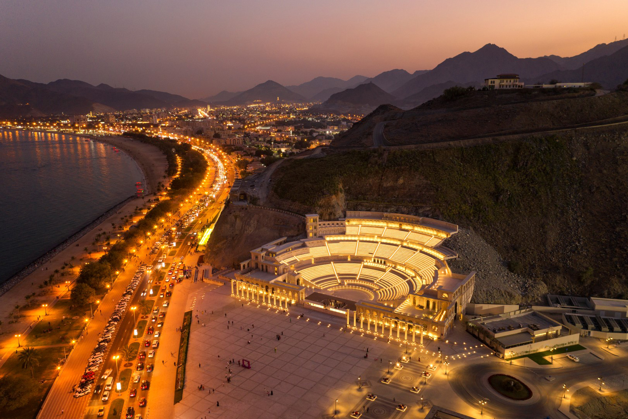

|  |
| --- |
| Logo Designs  2022 |
|  |
| MARCH 28  University of Sharjah  Name: *Atef Ahmed Mohamed U18105136* |

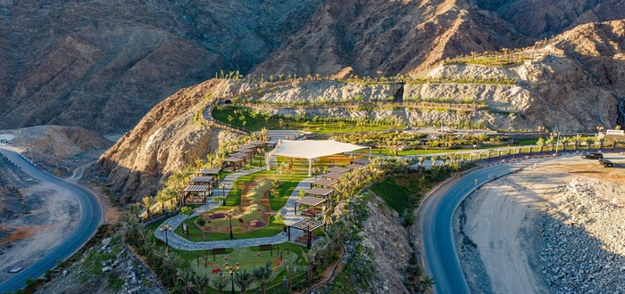

# Initial Idea

## Design 1

|  |
| --- |
| As seen in figure 1, the initial design contains a lot of elements which are all related to the University of Khorfakan and to the nature of Khorfakan. The mountains and sea of Khorfakan are both captured, as they reflect on its geographical beauty and marine biology studies within the university. The ship in the sea is Arabian Gulf design, which is the type of ship that was used in pearl diving and fishing in the region. Both Arabic and English versions of the University name are used as well as the short abbreviation ‘UKF’, **font** used is ‘**Dubai’** for both languages. Finally, the gear is part of the initial design, and it reflects the Engineering institute within the University of Khorfakan.  Color chosen based on the above related elements of Khorfakan, **blue** reflects the sea, **red** reflects the flag of Khorfakan, and **brown** for the mountains and hills of Khorfakan.    Figure 1    **As seen above, symmetry in the design wording is taken into account.**  Following up, the rest of the designs that follow have different changes that are derived from main initial design. Refer to table to find definitions of abbreviations in file names. Design 2 The second design can be seen in Figure 2, it is based on an atom and it contains in each of its orbits and element that captures the beauty and character of Khorfakan. The atom signifies the engineering institute within the university. The colors are the main colors in the Emirates flag (**red**, **black**, **white**, and **green**) showing the union history and significance to every region in the UAE, and that Khorfakan is part of that great union. Moving forward, the element in the red orbit signifies the Islamic structure that is built in, it has the book of Quran, Islamic dome and Islamic frame art. The black orbit contains the precious pearl that has great deal of history within the region. Finally, the white contains the great mountain, a geographical symbol of Khorfakan.  Fonts used are ‘**Adobe Arabic**’ for the Arabic text and English as well.    Figure 2    As seen above, symmetry in this design text is also taken into account. **Designs Alternatives** In the PNG file many versions of the original design can be seen, as well as different renders, ones with backgrounds and ones with transparent ones for each version.    **Figure 3&4** |
| The above figures are part of different abbreviation design using different outline like in Figure 2 and one using different font ‘Traditional Arabic’ and ‘Cambria Math’ in Figure 3. Figure 4 below shows the different font with the new outline (No outside gear)    Figure 5 **Kerning** Kerning here refers to the spacing between characters in the design, wide kerning is used in order to have logos suitable for printing in large formats, like banners. All bellow figures have wide kerning. Both designs can be seen side by side in the following gallery. |
| Figure 6, 7, 8 & 9  Both of Figure 6,7,8, & 9 are different color variation of the original design, showing the reach in the design coloration. **Design inspirations** Below photo was main boat inspiration design, boat was used for fishing and pearl diving in the gulf region.     |  |  | | --- | --- | | Abbreviations | Definitions | | P# | Picture number | | NKern | No Kerning | | WBG | White background | | Color | Different color than original design | | PNG8 | Different export PNG, smaller color variance and smaller file size than PNG24 | | WKERN | Wide Kerning | | C1, C2 | Color 1 variance and color 2 variance | |

Table 1